10. Tuning of autoISF settings for Full Closed Loop aided by the Emulator V.4.2
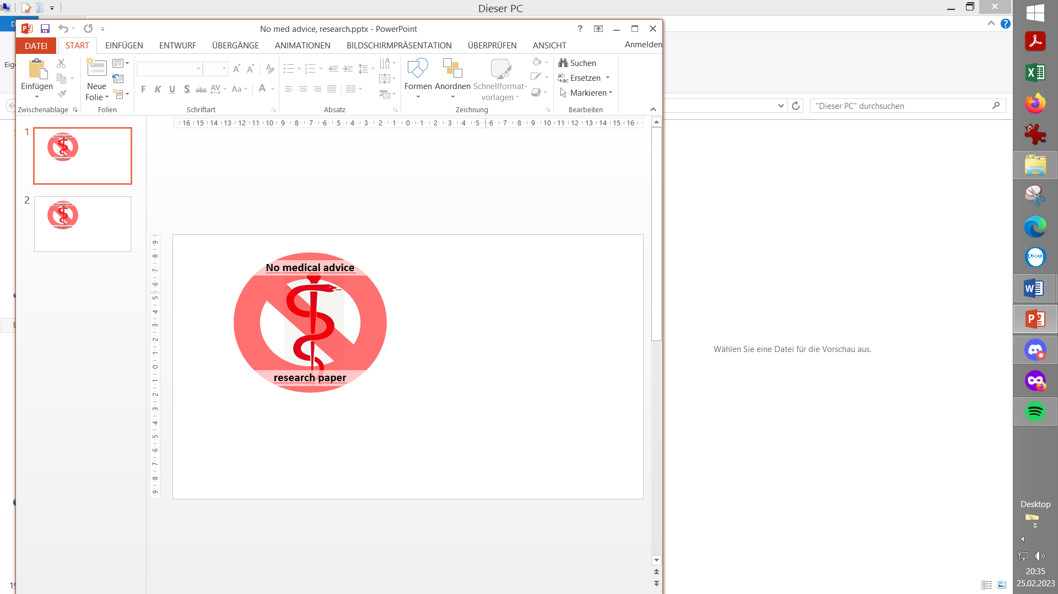
Please note that with autoISF you are in an early-dev. environment, where the user interface is not optimized for safety of users who stray away from intended ways to use. Good safety features exist, but these are only as good as the development-oriented user understands and implements them. This is not a medical product, refer to disclaimer in section 0

Available related case studies:

Case studies still missing:

Based on older autoISF and older emulator versions, examples from emulator use can be found in case study 6.2, in case study 4.1 (last pages there), and case study 8.2
10.1 Installing the Emulator on your PC
10.1.1 File structure on your PC
10.1.2 Load config and py files
10.1.3 Desktop button “Emulation_start”
10.1.4 Other software requirements
10.2 Analyzing loop decisions in logfiles
10.2.1 noChange.vdf
10.2.2/3 Locate logfiles / prepare Emulator
10.2.4 Run emulation and inspect results
10.2.4.1 .txt (all AUTO ISF tab infos)
10.2.4.2 Tabular (.csv) presentation of all loop decisions
10.2.4.3 Manual extraction of key data into .xls or .odc
10.2.4. 4 .pdf chart
10.2.4.5 delta table
10.3 What-if analysis
10.3.1 Define (yourChange).vdf
10.3.2 Run emulation
10.3.3 Inspect results
10.3.3.1 Logs (all AUTO ISF tab infos)
10.3.3.2 Tabular (.csv) presentation of all loop decisions
10.3.3.3 Semi-automated extraction of key data
10.3.3.4 .pdf chart
10.3.3,5 delta table

You can set up and tune the system for Full Closed Loop as described in previous sections.

Doing this by
- frequently analyzing screenshots that must be taken in real-time of the AAPS AUTO ISF tab
is tedious, however.
More elegant and precise tuning can be done:
- In a limited but fairly easy way via a new emulator approach by @faldor20:
Enter “ aaps-emulator.pages.dev “ in your web browser (Section or Case Study on this welcome!)
- Note that the iOS based variants of autoISF for Trio or iAPS (oref loops for i-Phone) can not use the emulator. However, the Trio or iAPS integrate on your i-Phone w very basic table that you can look up to see the contributions of the various autoISF categories to the past couple of loop decisions. (More see section 11.3)
- For Android users, deep analysis is enabled when using a special evaluation software for the AAPS logfiles, the emulator. It is described here: https://github.com/ga-zelle/APS-what-if / Documentation-in-English. There (under / Software) you find the files needed to download on your PC, and the primary instructions:
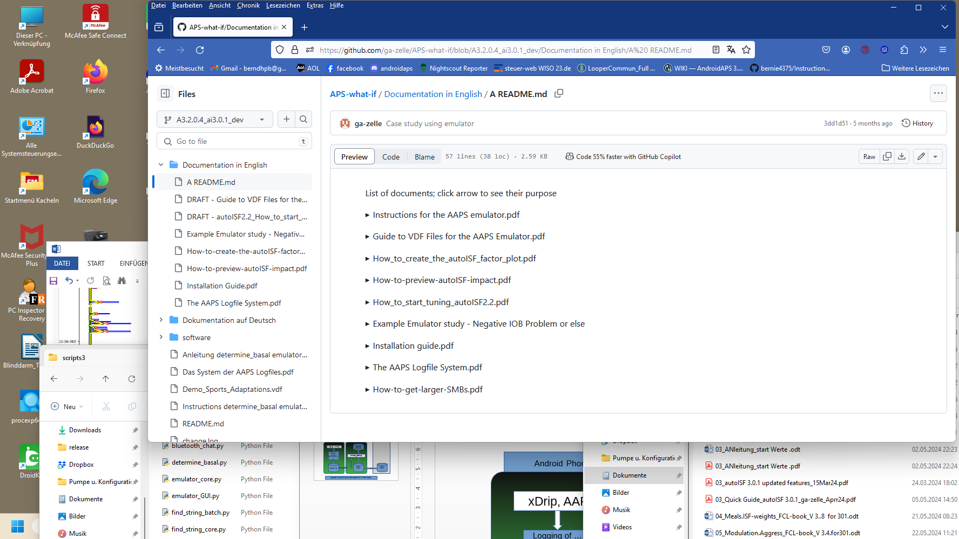
Note: Look it up in the most up-to-date branch
In the emulator, you can see in tabular and graphical form, which autoISF component, and other settings, contributed to SMB values that determined the glucose curve.
In the following, we look into how you create your relevant data. Application examples for tuning are given in associated case studies (we need newer ones).

Join https://discord.gg/n3tD5eXExC for seeking (and giving) help with the emulator set-up or use, and to exchange experience.

10.1 Installation of the emulator on your PC

Installation is a one-time process, and you best refer to the installation guide of the developer, here:
Instructions determine_basal emulator_AAPS3_ai226.pdf (or newer version) in:
https://github.com/ga-zelle/APS-what-if

Note that the emulator might not be up-to-date with a recent version release of autoISF. Check directly in Github (link 2 lines above), or see discussion here: https://discord.gg/n3tD5eXExC

Below, I attempt to spell out some additional details “for IT dummies” (like myself)

    - Create your PC folder structure
The suggested folder names and structure shown below is of course not mandatory, but only a suggestion.

On your PC, create a folder “Logfiles_Emulator” with 3 sub-folders: “AAPS _logs”, “Emulator” and “Emulator_Studies”
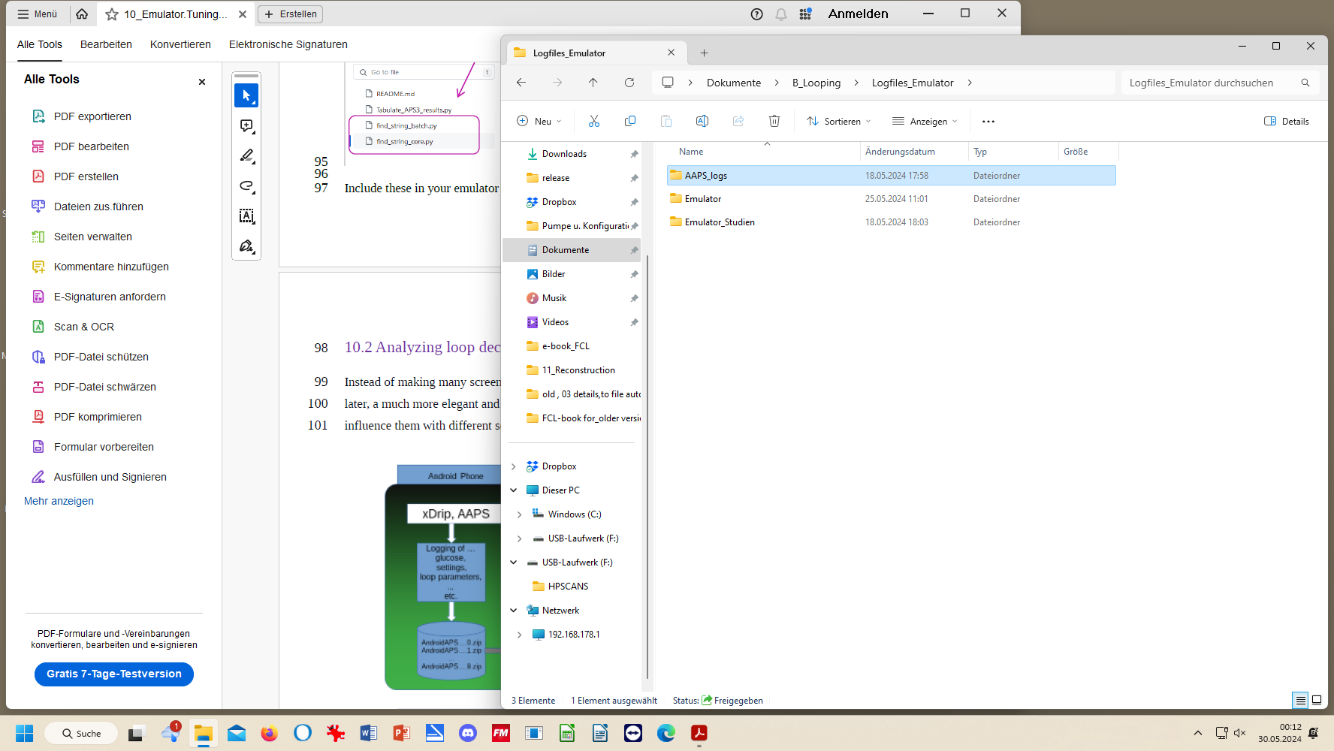

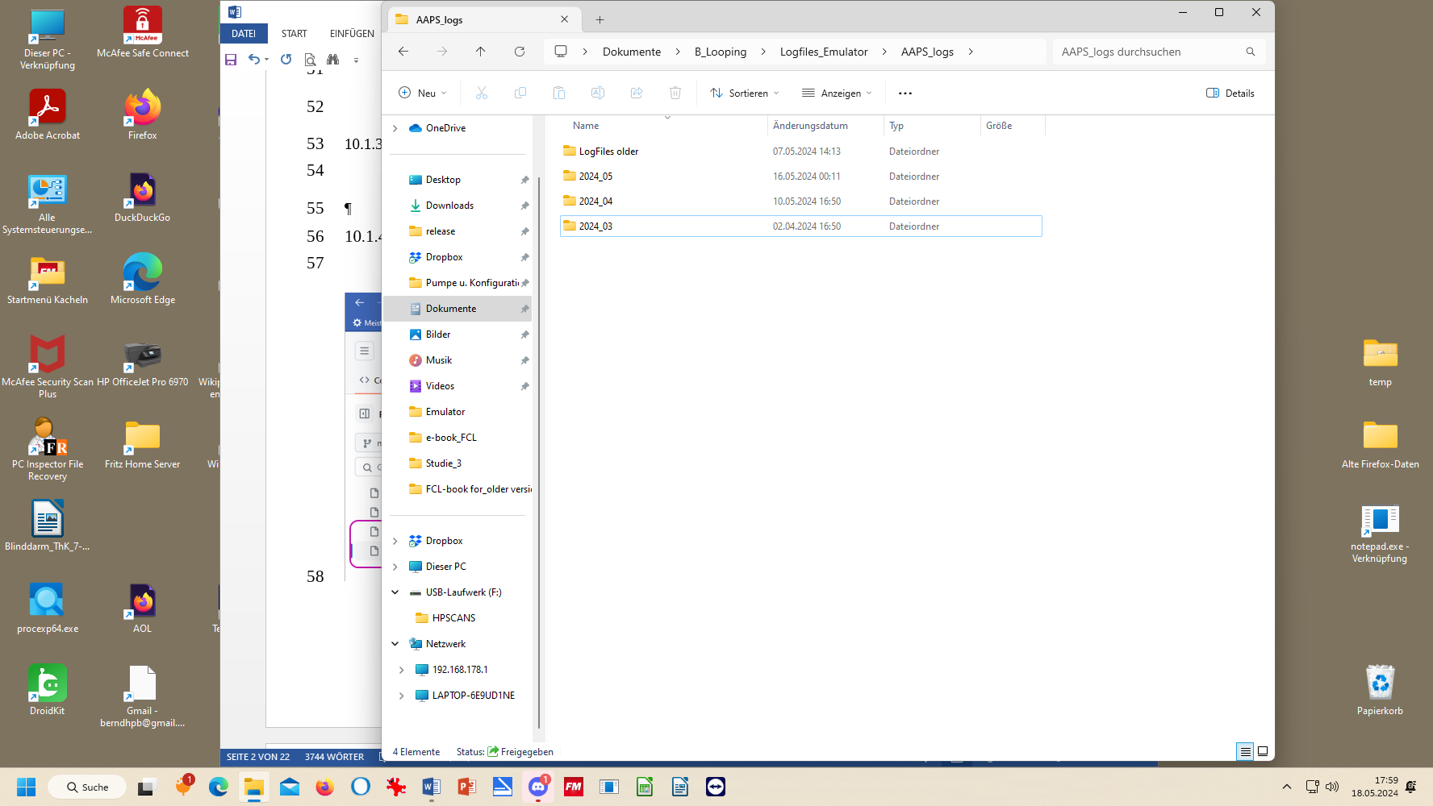

AAPS_logs: Put all your stored AAPS logfiles into that sub-folder. My folder structure for Logfiles and Emulation on the PC has 3 monthly folders, plus one folder with data from previous months and years (which I am less likely to analyze).
The logfiles you ALWAYS must copy-in from your phone before they get automatically erased there after x days (about 2 weeks, much shorter for 1-minute Libre3).
It is advisable to additionally store a pdf from Nightscout Reporter in the file for every month, with daily glucose charts, 24h scatter graph, etc. From it, you can much easier find which days and times are of high interest to analyze with the emulator.

.

Emulator: Neighboring “AAPS_logs” is the “Emulator” folder into which most downloads from the developer’s repo will go in section 10.1.2
Emulator_studies is a folder, where, for now, you should provide some sub-folders “Study_1”, “Study_2” … Study_n. Later, when you use the emulator, you will use these “addresses” for the program to dump results from the emulation into. Additionally you will probably put related AAPS screenshots and Nightscout.Reporter or xDrip/Statistics charts into each project folder to support analysis.

10.1.2 Downloads
1).Download from: https://github.com/ga-zelle/APS-what-if/ software, the .config and four py. files. To do this, you must (5 times, one at a time): click on the name here, and, for download, here
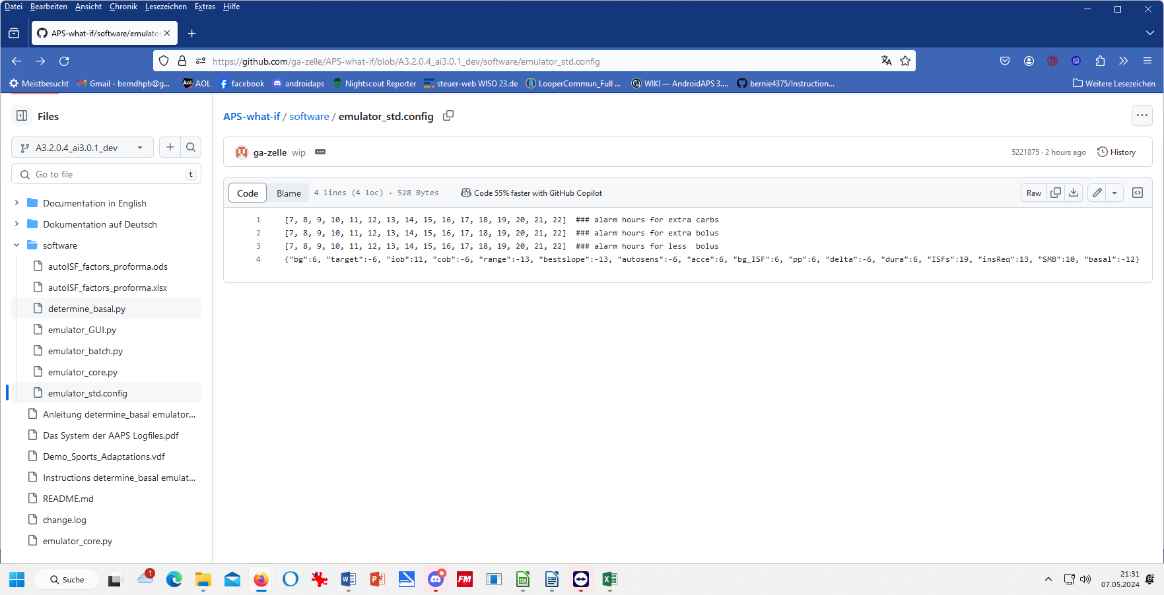
Always see to it that you are in the correct branch

Always make sure you use the files from the branch with the same version number as your AAPS version (in the example above: These files will work with AAPS dev version 3.2.0.4 with autoISF version 3.0.1). . Always keep your AAPS x autoISF and also the emulator related files up-to-date. If you can’t get your Emulator run, look in the Github repo whether there is a newer .py file (even with the same name; there may be updates that iron out problems that may have been reported only with certain AndroidOS versions etc etc))!!

2).Retrieve these 5 downloaded files on your PC (list of recent downloads), then:

3). Shift each of these 5 into your “Emulator” folder:

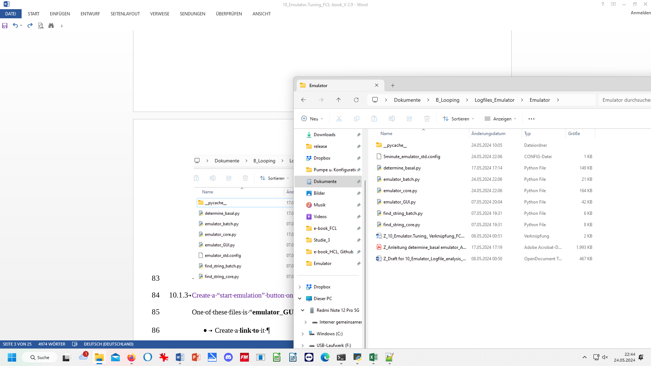 Note: Use 1minute:emulator_std.config in case you use Libre3 (1 min) as your CGM
see 10.1.2 .4)

4).From another section in Github, “Scan-APS-logfiles”, fetch two more .py files by
repeat steps 1)-3). for these two. They are from: https://github.com/ga-zelle/Scan-APS-logfiles/blob/main
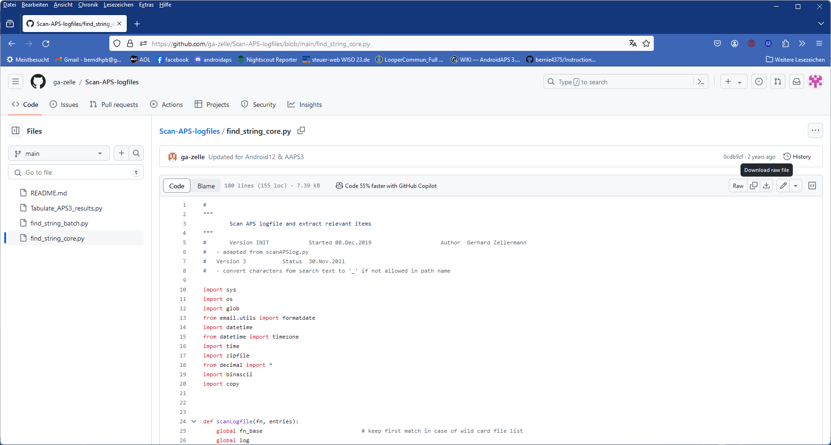

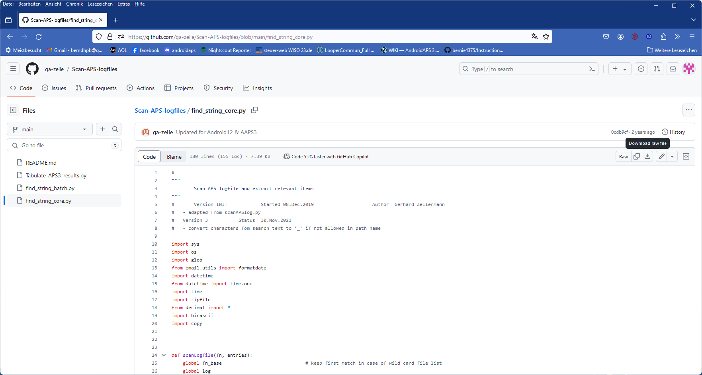

5)-Retrieve these two .py files in your PC’s downloads folder, and move them into your emulator file (as already was included two pictures higher up).

    - Create an “emulation start button” on your desktop
One of the files in your “Emulator” folder is “emulator_GUI.py“
- Create, in your Emulator folder, a link to it
- Drag that link onto your desktop
- Name it something like “Emulator_start”: This is your start button for emulations on the PC

    - Other software requirements
Make sure you have Notepad++ on your PC (see section 10.2.1).
QPython 3L will be needed on the smartphone, later (see section 11).

  - Analyzing loop decisions in logfiles
Instead of making many screenshots every 5 (or, w/ Libre3, every 1) minutes after meals, and analyzing them later, a much more elegant and powerful way to analyze your loop decisions (and how you might want to influence them with different settings, see section 10.3 for this), is to use the emulator.
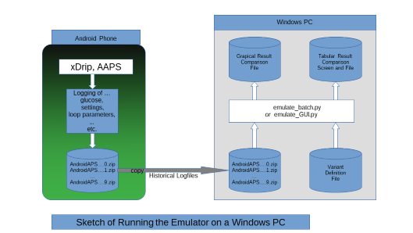
Github/ga-zelle / APS-what-if

10.2.1 Set up a “no change” .vdf file.

1).To do this, just open Notepad++ (from list of all programs on your PC).

2). Name your file “noChange.vdf”.
It is just empty in the lines that would define any change to be investigated.
Note: for “what-if” analysis, entries will be made (in a second .vdf later, see section 10.3 )
The no change .vdf should look like something like this:
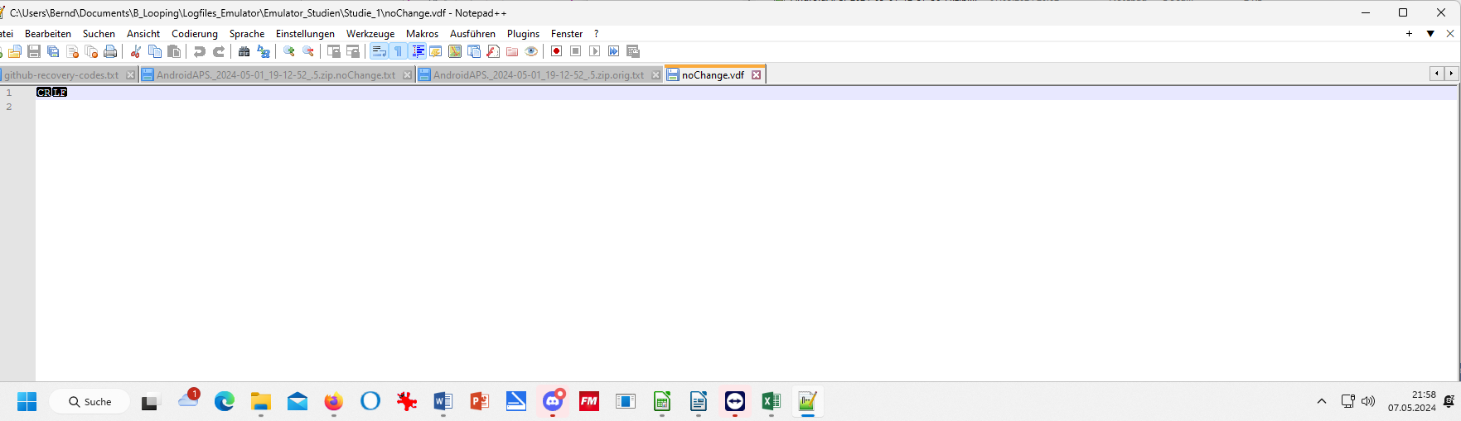
Lines 1 and following should all be free (CR LF might show, depending on your settings in your WORD program)

3).Store that “noChange.vdf” in your “Emulator studies” folder, on the top level, besides the single studies folders
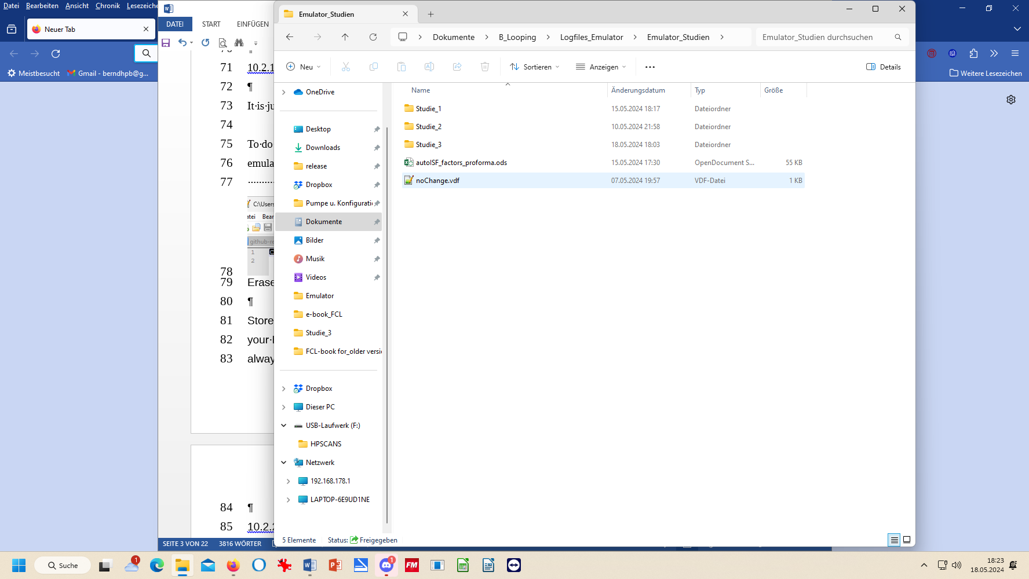

4).From that position, you always make a copy, and paste into each Study_1 …n :

See section 10.3.3.3. regarding this ->
3x copy / paste

10.2.2 Locate relevant logfiles and prepare the Study_n folder

1). Make sure you have the AAPS logfiles that you want to analyze in your “AAPS_logs folder”

2). In your “Emulator_Studies” folder, create (or use a prepared) “Study_n” sub-folder, with a copied-in (not: moved!) noChange.vdf (It must be in all Study_n files).

10.2.3 Prepare your emulator run for Study_n

Now go to your PC desktop, and start the emulator by just pressing the button “emulator start” that you installed in step 10.1.3
This opens a big dialogue box with 3 fields that you must fill in with the applicable path (without any
quotation marks “..”) from your Windows Explorer file system, best done via (3x) Browse button:
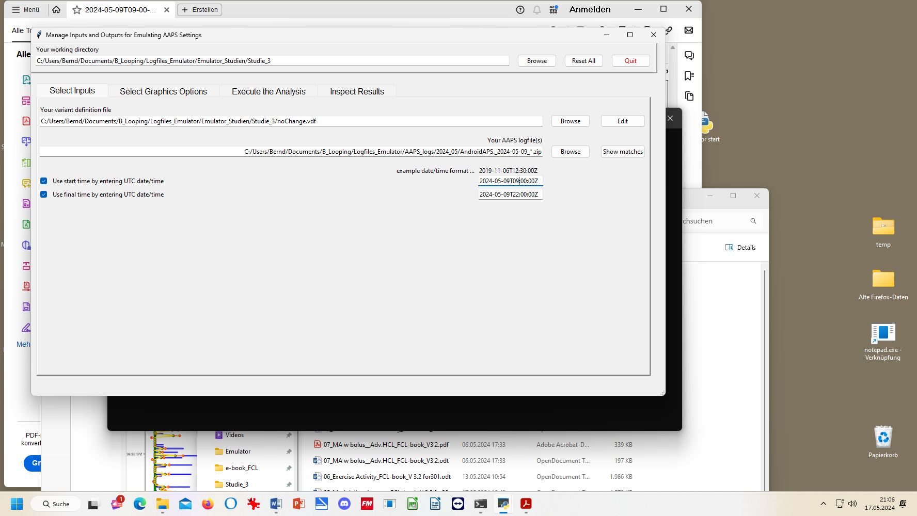
- The top box marks the path to your current emulator project (“Studie_3” is my “Study_n” where I want to store results)
- The middle box marks the path to your current vdf (what kind of analysis; here: “…noChange.vdf” = read-only. (For what-if, see section 10.3)
- The third box marks the path to your AAPS logfiles you wish to look into. A good way to do this is:
- Browse in your Windows Explorer to any logfile from the desired day (2024-05-09 in above example)
- Replace the time with an asterix * (this means you look at all-day data, in UTZ time). Check whether this will work by pressing Show matches . You should see all logfiles from that day in a pop-up info box.
- As I wanted to look at 11 am –midnight (for lunch and dinner related data), I :
  - clicked the bottom left two boxes
  - copied the date 2024-05-09 over the default date in the bottom right two data fields
  - after T (for time), I entered the desired time of analysis AFTER conversion into my local time (Central EU summer time minus 2 hours = UTZ; so to look at 11 to midnight of my AAPS screen, I must enter here 09.00:00Z, and below it 22:00:00Z).
Entries at the bottom are not mandatory, but when clicking these little boxes (bottom left) you can define a start and/or an end-point for analyzing, within the logfiles specified in the field above.

10.2.4 Run emulation

Now we are ready to go: Press “Run emulation”
This produces sometimes an error message (e.g. if you have a syntax error, or incompatible software versions: => seek help, in the Github materials provided by ga-zelle, or in Discord/Full-Closed-Looping/emulate-aaps here: https://discord.gg/n3tD5eXExC

After a short moment results should show up, which you can look into in a couple of ways.

Optional: You could have a quick look into the .log file to see whether the run had errors (see section 3.8)

      - AUTO ISF tab contents in (date..) noChange.txt result file
This …txt file basically gives you “all the AUTO ISF tab” infos, in a super long list (but without needing to make screenshots in real-time, every 5 minutes.)
Search options help find what lines are of interest to your analysis:
By using the search function you can jump, in that super long list, to all places that e.g. have „autoISF“ in it or „script debug“, or „SMB disabled“ (if you want to analyze when that happened). Precise spelling, as in this .txt (or in AUTO ISF tab) is of course important.
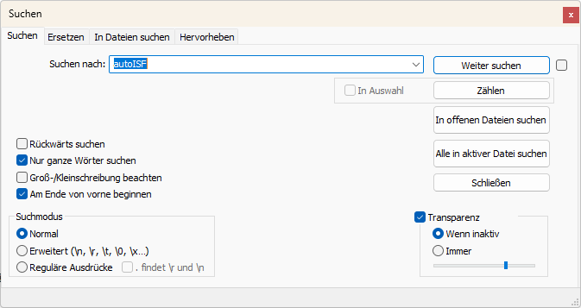
search term
press to go to next place w/ it

10.2.4.2 Table of results (…noChange.csv file)

The .csv file in your project folder gives a tabular presentation of how parameters like bg, iob, iobTH, the various ISF contributors, bg target, insulinRequired etc. develop every 5 minutes, and what SMB size and %TBR resulted.
It is a vast table, so you may want to reduce it to something more “digestible”, either after transfer to your standard calculation program (next section 10.2.4.3). Or you can also make settings to suppress information you are usually not interested in (or do not know how to interpret, anyways) under “Select Graphics Options” when you open the emulator, before executing any analysis:
First, select your preferred way of outputting decimals (point or comma).
Then select whether you want “All” possible outputs in the graph, or “Most” = all except those you tick “off” in the boxes for each output parameter.
In case you would use “Some/just a few”, you would have to tick those few you that do want to see, by ticking the corresponding boxes.
Recommendation is to look at (nearly) everything offered (as your default setting that you can leave untouched in most of your emulator runs):
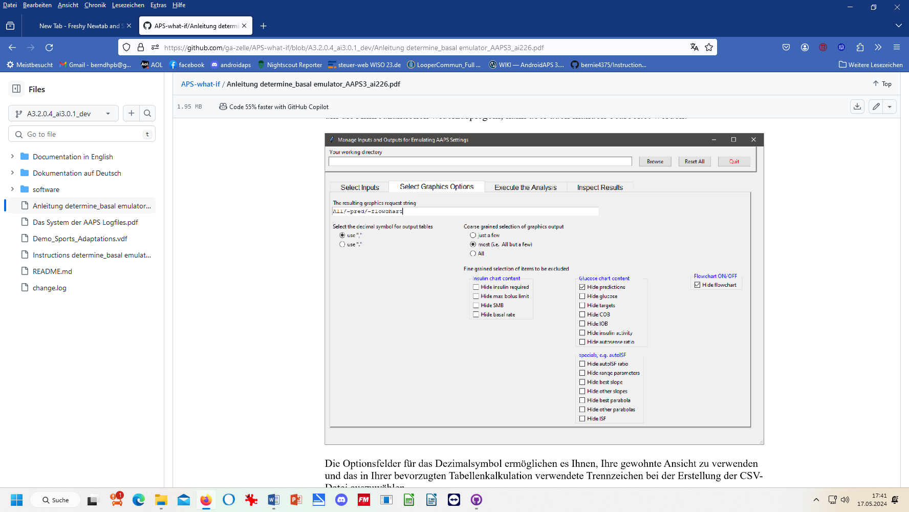
It might be easier, to not deal with customizing the csv file, and rather copy the data into your favorite calculation program:

10.2.4.3 Analysis of the noChange.csv table in Excel or LibreOffice calc.

Best copy the entire table into a new .xls or .ods sheet, where you can:
- add right next to the UTC (Unix Time Code) your corresponding “AAPS time”
For instance, adding +2/24 translates the UTC column into central European summer time column next to it (where currently a row of Z stands). Likewise, subtract like -5/24 from UTC for an US East Coast time scale. (Fun fact: Our oref loop stubbornly works on UTC, un-impressed by our folly to jump twice a year into or out of a local summer time, or to travel across time zones. If some data get lost in translation there, it is only to us, with our stupid time change. For the loop, its database (e.g. on insulin activity) remains unambiguously intact).
Highlight all time fields (both entire columns), and switch from hh:mm:ss format to hh:mm. (While the seconds are important for the loop’s calculations, for our comparison with Nightscout or other charts and data, it is much easier without the seconds attached)
- hide any column you find less important to look at for your intended analysis
That way, “boxes” (data fields) retain their original position in tables
Also, in case later you want to look into additional info, you can simply un-hide the relevant columns (or lines:.)
- hide lines (time segments) you find less important to look at for your intended analysis

Usually you will color mark where relevant SMBs were given, which of the ISFs (and underlying weights) was strongly contributing (note that this can be good or not good). Also where iobTH was exceeded, whether an Automation kicked in e.g. setting a TT, or when there were periods with zero insulinRequired.
In section 10.3.4 we present an extra tool that does a standardized table reduction and color marking for you!
You may be able to formulate a hypothesis or two, what settings (…ISF_weights, iobTH%, SMB_range_extention, autoISFmax …) should be changed for improvement (then go to 10.3)

10.2.4.4.. Graph noChange.pdf

After your emulation run, under Inspect Results, you can open the pdf file that is last in the results list offered.

This noChange.pdf is a chart that shows along the time axis (down), from right to left:
- Red: the bg curve
- Yellow: the bg target (note that I do no manual “EatingSoonTT” but for bg rises over +10 mg/dl I have an Automation that sets low TT for a couple of minutes)
- Light blue corridor: Left edge is set iobTH, and bandwidth +30% (would be +20% at elevated TT)
- Dark blue line: iob (exceeding twice the iobTH, with temp. SMB shut-off
As bg did not convincingly come down enough, one could hypothesize that iobTH should be elevated. ((But, again, this would have to be confirmed also with other kinds of meals)).
- Thin yellow line: Insulin activity
- Green dotted line: ISF as would result from AAPS w/Autosens
- Green scatter points: autoISF ISF no Chage (lighter points) or what-if (darker points)
- Black line: Profile ISF
- Gray scatter points: ISF weakened (to the left of black line) or strengthened (to the right)
- Orange line: cob=0 at all times (in FCL)
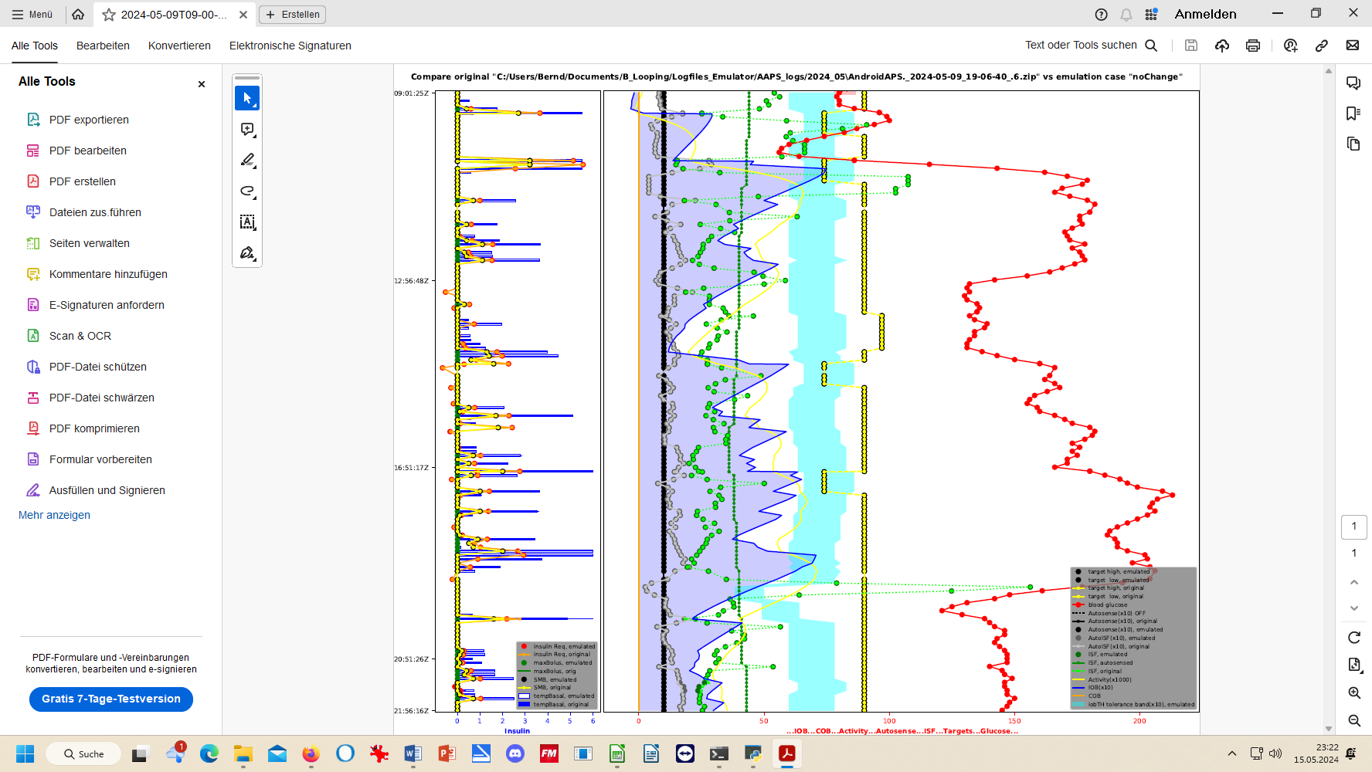

More see discussed together with (yourChanges).pdf in section 10.3.3.4

10.2.4.5 delta table
In case you want to analyze delta, short and long average deltas:
- you could do some of that just using your .xls extract from .csv (see section 10.2.4.3).
- There is also an extra sheet provided, “delta” (That works only if you have your emulator_core.py updated to the one from 02June2024 or newer).
- This is definitely core to FCL using Automations (section 13.1).
- When using acceleration detection via autoISF, the deltas are mainly meaningful to define personal Automations that involve Conditions using these glucose curve characteristics. An example would be to use the delta table to identify cases of compression low

  - “What-if” analysis using the emulator

In the following you see an example how you can analyze a day of logfiles, and selecting the time span of interest, for instance 11-24 h to look at how autoISF managed lunch and dinner.

You will go through the emulator exactly as you already did in section 10.2. where you exclusively had the noChange.vdf on bord.
However, this time you focus on (yourChange).vdf, see below, 10.3.1..
Repeat, if you have two or more such vdf defined.
(Just clear old results before pressing “execute analysis” each time.)

All results are automatically captured for all runs, all in your selected “Study_n” folder, together with the noChange results
- Results files with noChange in their name are always your actual loop data …
- as opposed to results on “what-.if , that contain name of the (yourChange).vdf in their file name see e.g. at around line 380

How to proceed, step by step:

10.3.1 Define your investigated changes in (yourChange).vdf (one,. or several)

1).Define for which parameter(s) in your current profile settings you want to look into a different setting. Recommendation is to use a factor, like for example: current setting * 0.9 , or current setting * 1.2, and use that in your naming for this vdf file, too.
You may want to consult APS-what-if /Documentation in English/Guide to VDF Files for the AAPS Emulator.pdf Access directly, or via section 3.8

Within one study, you can make several emulator runs with several (yourChange).vdf files (all based on what really happened, as captured with the noChange.vdf).
All results, like the csv results table, will appear then several times in your study file, only with different name endings as in the underlying vdf.

Example: I like to check in my actual data (they are in my noChange.vdf emulator run), in which time points the following parameter changes would make a (how) big difference in the loop’s decision:
- 20% higher bgAccel_ISF_weight to boost the first SMBs stronger: How would that tend to ramp up early iob; and might that get too strong in other parts of the data? Or does it bounce into a restriction (maxSMB size; autoISFmax; iobTH…) that I might need to widen?
- Doubling my cautiously set bgBrake_ISF_weight shall give me insight into the workings of that parameter (and whether using a much smaller weight than for bgAccel_ISF_weight is really what I should keep doing)
- As my bg came down from a persistent high quite slowly, I elevate the dura_ISF by 20%

Tuning advice: Actually, it would make more sense to first find my “optimal”, maybe indeed elevated, bgAccel_ISF_weight. Then, in a new project_n+1, do (automatically) a noChange run with that, plus a (yourChange) run with the stronger dura weight, investigated on that basis. Reason: 1) As we always say, better do only one change at a time. 2) A better job with bg control via bgAccel_ISF will reduce the peak height and provide a different (easier) scenario for dura_ISF to manage.

2).Now, to write your (yourChange). vdf for the emulator (this is same procedure as you did in section 10.2.1 for the noChange.vdf):

- just open Notepad++ (from list of all programs on your PC) to create a new vdf:.
Alternatively you can also take another pre-existing vdf file, copy it into your current project , edit as desired, and give it a new name (re-name it)
Caution: Make absolutely sure (best by looking it up in the AUTO ISF tab, down in the profile set section) to spell each term exactly as your loop uses it (probably w/ decimal points, not comma)
2.1) Investigating simple setting changes by a factor multiplied with the former value
- …when you make one line per parameter (separating entries with spacers->):
profile->(parameter) ->->profile[‘(parameter)’]*(factor)->->###(comment as you like)

The (yourChange) .vdf should look like something like this:

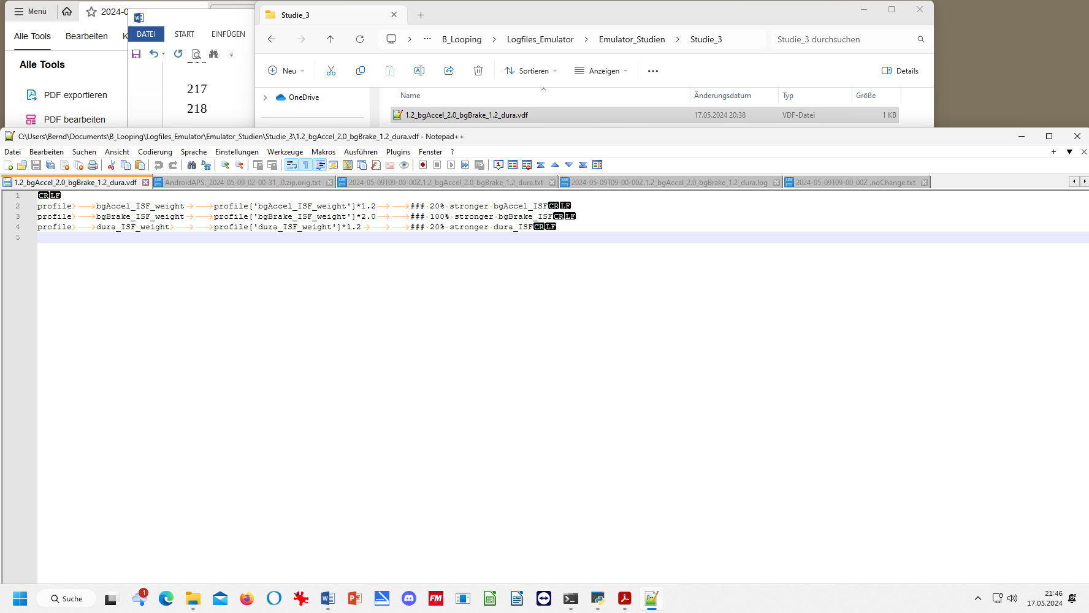
Via view/ show/hide symbols (CR , LF, tabs …), you can have different looks, see other example two pages down.
Or, with settings/view/remove symbols (for line feed, tab etc) it can also look like this:
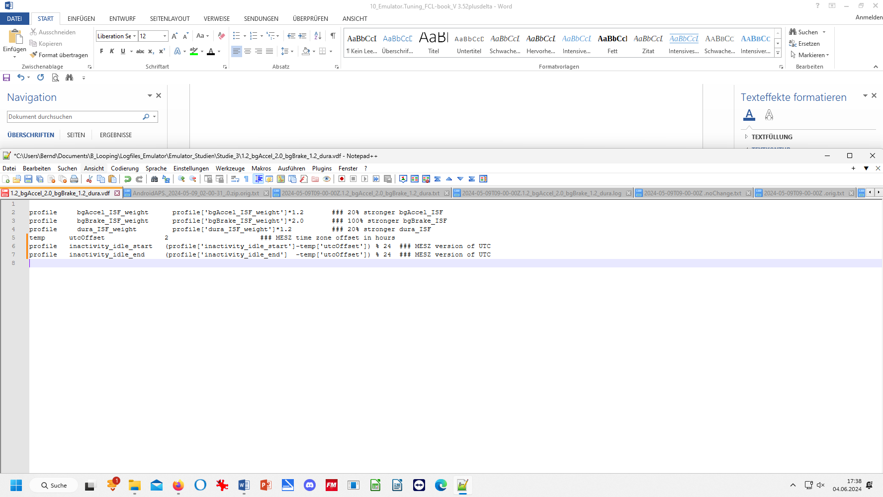
2.2) More complicated vdf files are needed if it is not just a factor applied to a setting. See APS-what-if /Documentation in English/Guide to VDF Files for the AAPS Emulator.pdf. One example from there:
In the VDF you can also define your circadian tables for ISF, CR and basal. You need to pay special attention to the difference between UTC time and your local time zone for the pump. Here is an example for CET (Central European Time):
STAIR_ISF 00:00:00Z 45 ### 01h_C(entral)E(uropean)T(ime) or 02h_CEST
STAIR_ISF 01:00:00Z 44 ###
STAIR_ISF 02:00:00Z 42 ###
...
STAIR_ISF 17:00:00Z 36 ### 18h_CET
STAIR_ISF 18:00:00Z 38 ###
...
STAIR_ISF 22:00:00Z 43 ### 23h_CET
STAIR_ISF 23:00:00Z 44 ### 00h_CET
profile sens STAIR_ISF ###

STAIR_CR 00:00:00Z 8.0 ### 01h_C(entral)E(uropean)T(ime) or 02h_CEST
STAIR_CR 01:00:00Z 7.5 ###
...
STAIR_CR 20:00:00Z 7.5 ###
STAIR_CR 21:00:00Z 8.0 ###
STAIR_CR 22:00:00Z 9.0 ### 23h_CET
STAIR_CR 23:00:00Z 9.0 ### 00h_CET
profile carb_ratio STAIR_CR ###

STAIR_BAS 00:00:00Z 0.41 ### 01h_C(entral)E(uropean)T(ime) or 02h_CEST
STAIR_BAS 01:00:00Z 0.43 ###
STAIR_BAS 02:00:00Z 0.44 ###
STAIR_BAS 03:00:00Z 0.50 ###
...
STAIR_BAS 19:00:00Z 0.75 ### 20h_CET
STAIR_BAS 20:00:00Z 0.75 ###
STAIR_BAS 21:00:00Z 0.60 ###
STAIR_BAS 22:00:00Z 0.45 ### 23h_CET
STAIR_BAS 23:00:00Z 0.43 ### 00h_CET
profile current_basal STAIR_BAS ###

Some lines were omitted in that example for better readability. The lines must be sorted by UTC time. Therefore the first line (winter time) or first two lines (summer time) from your CET/CEST based pump definition must be cut off and appended at the end. If your profile is not fully populated for 24 hours this may also mean you first need to create a pump entry at 01 or 02 hours, respectively.
To have such a vdf file ready is a great idea for investigations into changes of your profile: See section 11.4 for how to get a voice literally tell you, whenever the new profile would actually make a difference, and you having the choice to watch performance with ‘) or without that change ( * only if the new profile makes more aggressive settings)..

3). Name your vdf (in example below: 1.2_bgAccel_2.0_bgBrake_1.2_dura.vdf) …

4). Store this (yourChange).vdf in the folder for your current Study_n you are about to start (see my storage path C: ….. Studie3……….vdf – Notepad++ in the top line:)

10.3.2 Run the emulator with (yourChange).vdf

The “what-if” emulator run is done the same way as you did the noChange.vdf run (section 10.2), which had no (yourChange).vdf on bord
=> No surprise, running an emulation with only that noChange.vdf, yields same result in emul columns as is orig columns. - However, now :

The (yourChange).vdf must be loaded into the 2nd input field, where formerly you had the noChange.vdf.:
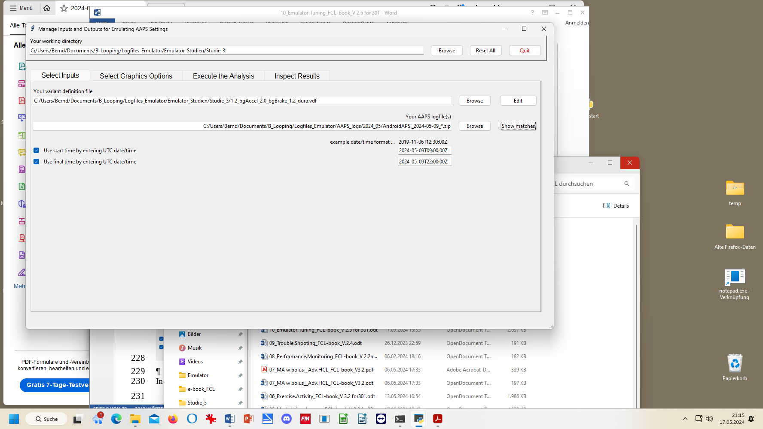

In the 3rd input field, give the path to your stored logfiles. A good way to do this is:
- Browse in your Windows Explorer to any logfile from the desired day (2024-05-09 in above example)
- Replace the time with an asterix * (this means you look at all-day data, in UTZ time). Check whether this will work by pressing Show matches . You should see all logfiles from that day in a pop-up info box.
- As I wanted to look at 11 am –midnight for lunch and dinner related data, I :
  - clicked the bottom left two boxes
  - copied the date 2024-05-09 over the default date in the bottom right two data fields
  - after T (for time), I entered the desired time of analysis AFTER conversion into my local time (Central EU summer time minus 2 hours = UTZ; so to look at 11 to midnight of my AAPS screen, I must enter here 09.00:00Z, and below it 22:00:00Z).
After making these entries, press Execute the Analysis, (evtl also Clear old Data) and then press Run Emulation, you can look the results up under “Inspect Results”. First you could have a quick look into the .log file to see whether the run had errors (see section 3.)

10.3.3 Emulation results

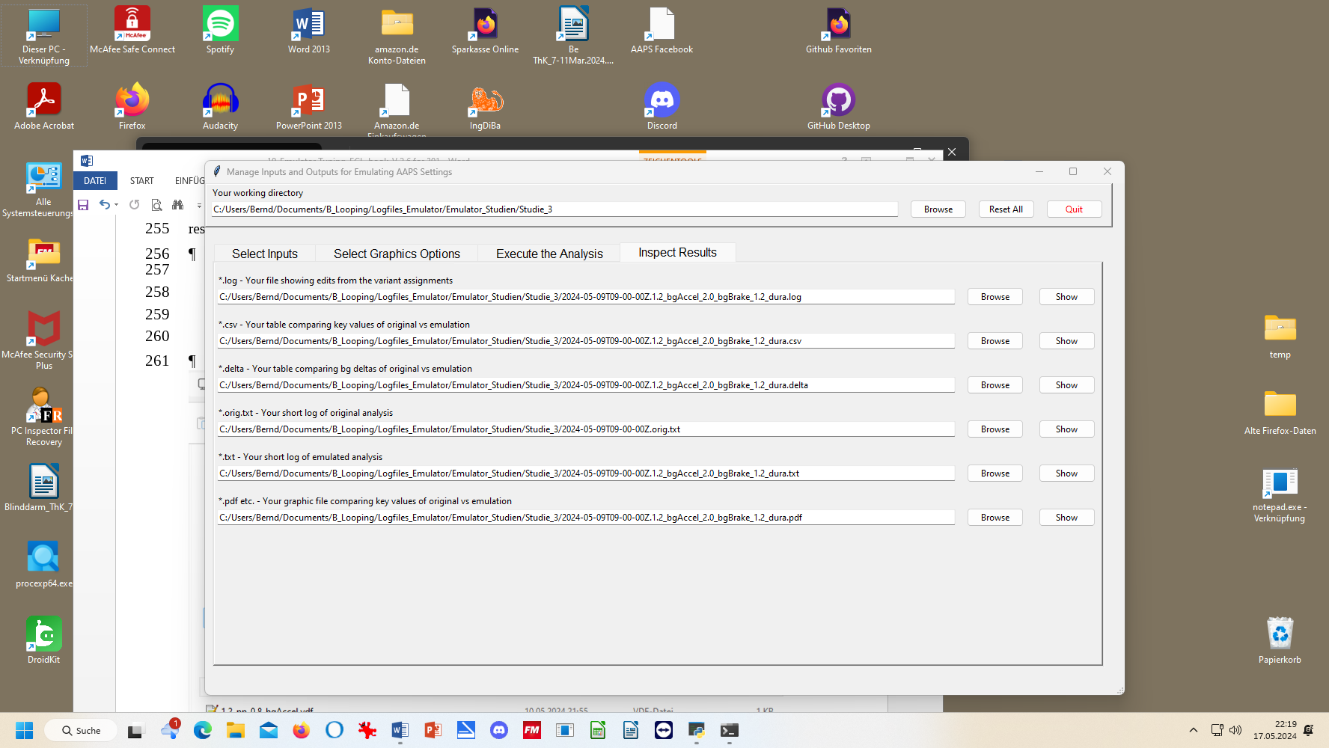
All results from your (yourChanges).vdf emulator go automatically where the noChange.vdf results are already stored, in our example into the “Studie 3” file, below:

Besides the 1.2_bgAccel_2.0_bgBrake_1.2_dura.vdf case which I like to look into for the present high carb meal, I also prepared another vdf that investigates a factor 1.2 stronger pp_ISF and a weaker, factor 0.8, bgAccel_ISF (with the intention to test this, and a noChange (that ideally would already contain the conclusion on adapting the bgAccel_ISF_weight*), on a low carb meal later.
* Note the challenge here is to iterate between the typical meals of your personal spectrum to find one set of settings that work good-enough for all of them.
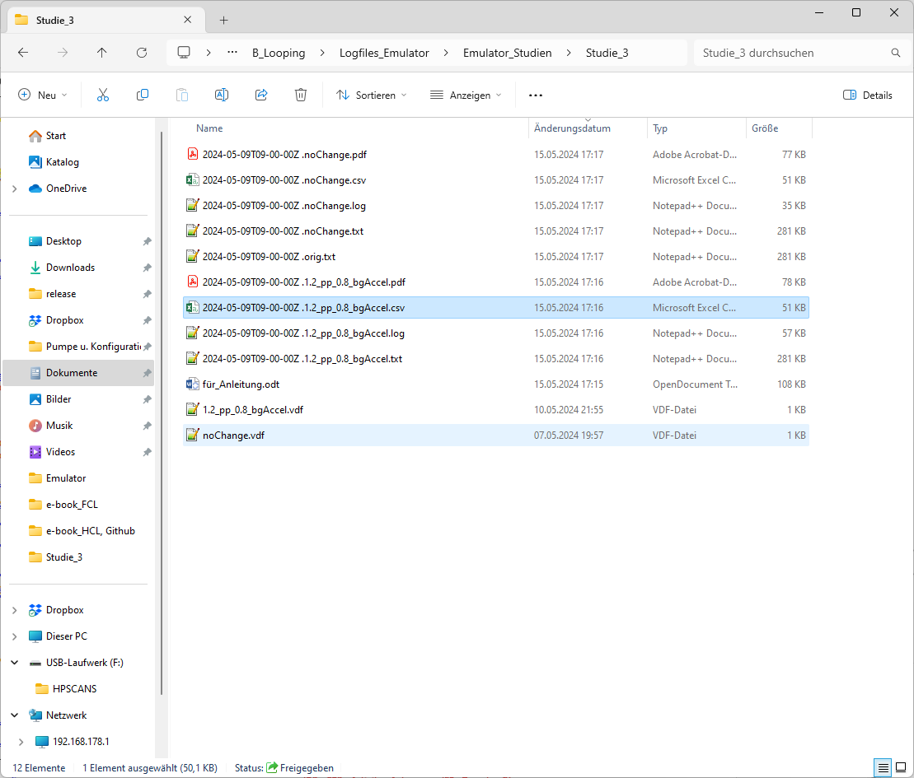
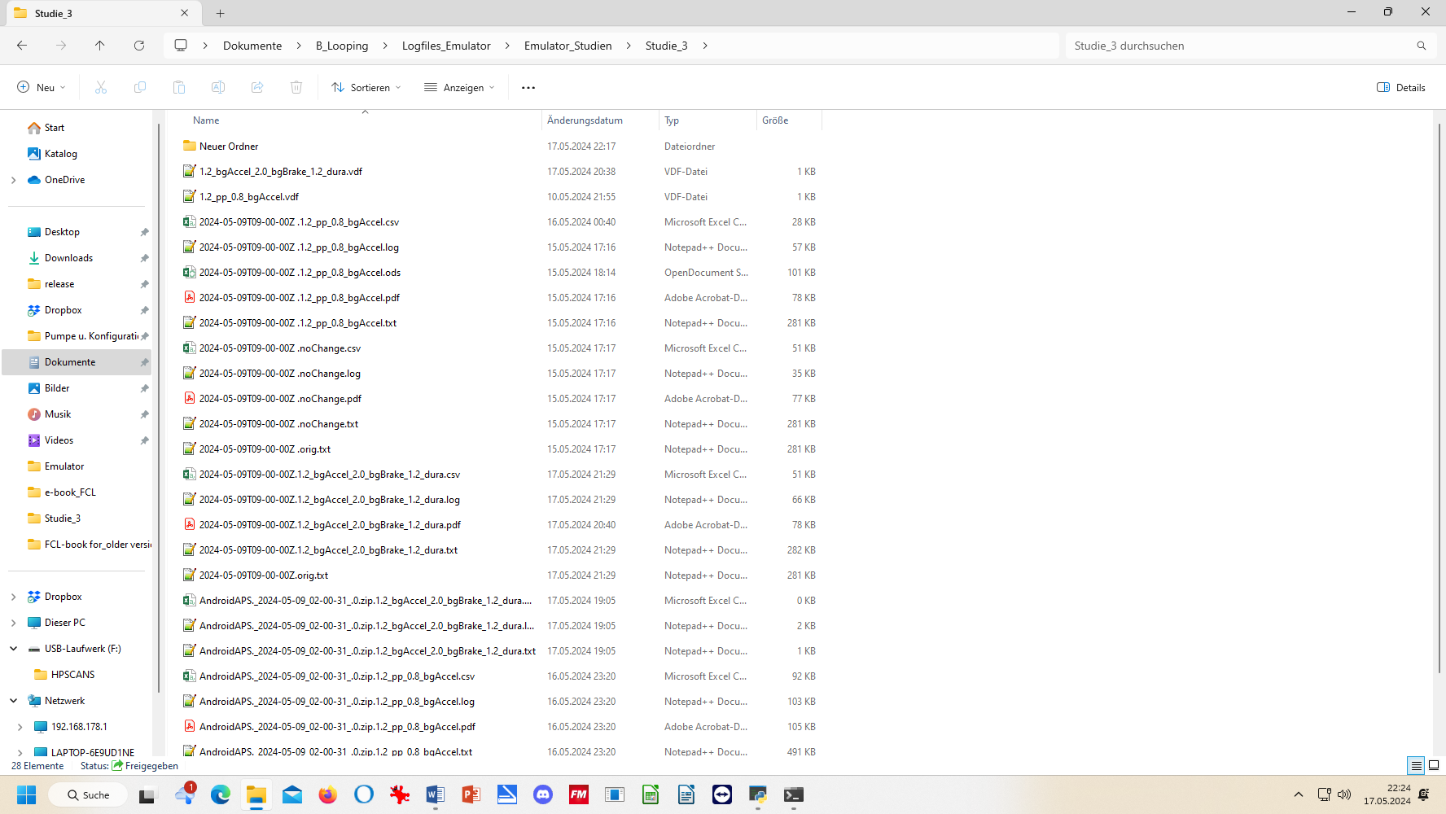



10.3.3.1….(yourChange).txt: “what-if” impact on loop decisions (as in AUTO ISF tab )

The noChange.txt has all the info your series of AUTO ISF tabs had that day.
How to search in this vast list is shown elsewhere (see section 10.2.4.3 ).

Likewise, the (yourChange).txt gives for each loop decision in all detail how and why each single decision would have changed with the different parameter inputs you are checking out here
In the two (yourChange) examples here, , it was a check on the difference
- a 20% stronger pp_weight and 20% weaker bgAccel_weight
- a 20% stronger weight for both, bgAccel_ and dura_ISF, and a doubling of bgBrake_weight
would make.

Note that all these “what if” data can only give rough hints, notably about the first greater change that you would see with the investigated changed setting. So it works quite well for our main problem in FCL, investigating how to ramp up iob quickly after detection of acceleration.
Note that any relevant change would put your bg curve on a different trajectory, so that would influence all following results. Therefore, what you get here is not a complete modelling how your bg would have developed in the alternative scenario.
But you can investigate in which stages the parameter(s) you are looking at in your current “what-if” had big influence, and in which direction the changes would go. (see also charts shown in section 10.3.3.4).
Analyzing how to safely come down from a high glucose plateau while limiting hypo danger towards the end of digestion is also to some extent possible.

A good other way to employ the what-if analysis is real time, on your smartphone, using speech synthesis (see section 11): Then you get real-time info, as to exactly when a significantly different proposal would emerge, and can decide (and watch!) real-time whether to follow the new idea and not was probably better.

Observe that a setting change must work well for you
- not just in one point of time, and
- not just for one kind of meal,
but you must look at all time slots in the investigated meal, plus analyze with the same tool a totally different meal within your usual spectrum, how things work out there

      - Tabular results

- .csv results table and spreadsheet copies of it

The noChange.csv table gives all relevant data. Besides development of bg and iob you see the calculated insulinRequired in each loop decision, and how each of the autoISF categories contributed to the decision (notably regarding SMB size).

Note that the “acce_ISF” results are only in case of positive acceleration (that is our main focus) driven by the bgAccel_ISF_weight setting. (These are all positions > 1.0 in the “acce ISF” columns).

In case of negative acceleration (decelerating rise, positions < 1.0 in the “acce ISF” columns), bgBrake_ISF_weight is applied. As discussed in section 4.4, bgBrake_ISF might be most important (and interesting to analyze) in slowly resorbing meals.

Note: maxBolus=0 means in this table that SMBs were not capped by maxBolus.

The (your change).csv shows in detail how every single loop decision would be influenced by the different settings you are investigating.
To inspect that huge table, click on the Z behind the start UTC time entry (see black box in the Z column of the table, next page).
If you like to see the bg in each screen, too, go 3 or 4 columns farther to the right with your black box.
Then, go to window/fix. Now you can scroll through the data and always see headline and time (or time and bg level).
To further ease analysis, feel free to temporarily erase (hide) any columns that you (think you) do not need for the intended analysis. More suggestions see in section 10.2.4.2
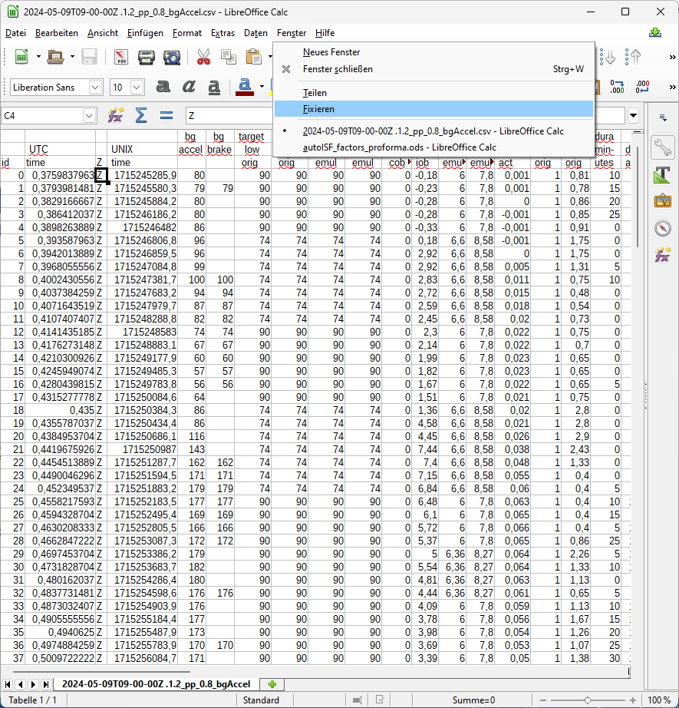

Still, the csv tables are overwhelming. You could proceed in either of two directions now:

- Convert both (or all 3) csv files into one table in Excel or into Libre office calculator. Hide columns (and eventually also lines) that are of no particular interest for your analysis. Mark differences between noChange and (yourChanges) column data with color, add extra columns with additional calculations …
This route is good to compare quantitative impacts of autoISF categories in critical time points.
- For the core data relevant to assessing your autoISF settings, there is an extra tool for convenient analysis - see the following section 10.3.3.3
That tool is quite a bit of work to set up. Decide for yourself whether you do it, or whether you rather work with extracting the csv table into Excel (A), and work freely from there.
      - Automated extraction from tabular results (optional add-on)
Decide for yourself, whether you rather go from the csv results table into .xls and produce what you want to see there for yourself.
With a bit of extra set-up effort (steps 1)-7), next 4 pages) you can install an adjunct tool that will always produce the nice graph for you as shown on the end of this section 10.3.3.3, in step 7).
Realizing that going through the following steps 1) – 7) is currently quite complicated, the developer is working at radically simplifying it in an update to be expected this summer (2024). If you feel a bit challenged, we suggest to just wait for this update, which will largely be embedded in a newer version of the autoISF_factors_proforma.ods, see next section.

1).autoISF_factors_proforma.ods is provided as an extra tool that you download from here:
www.github/ga-zelle/APS-what-if/software
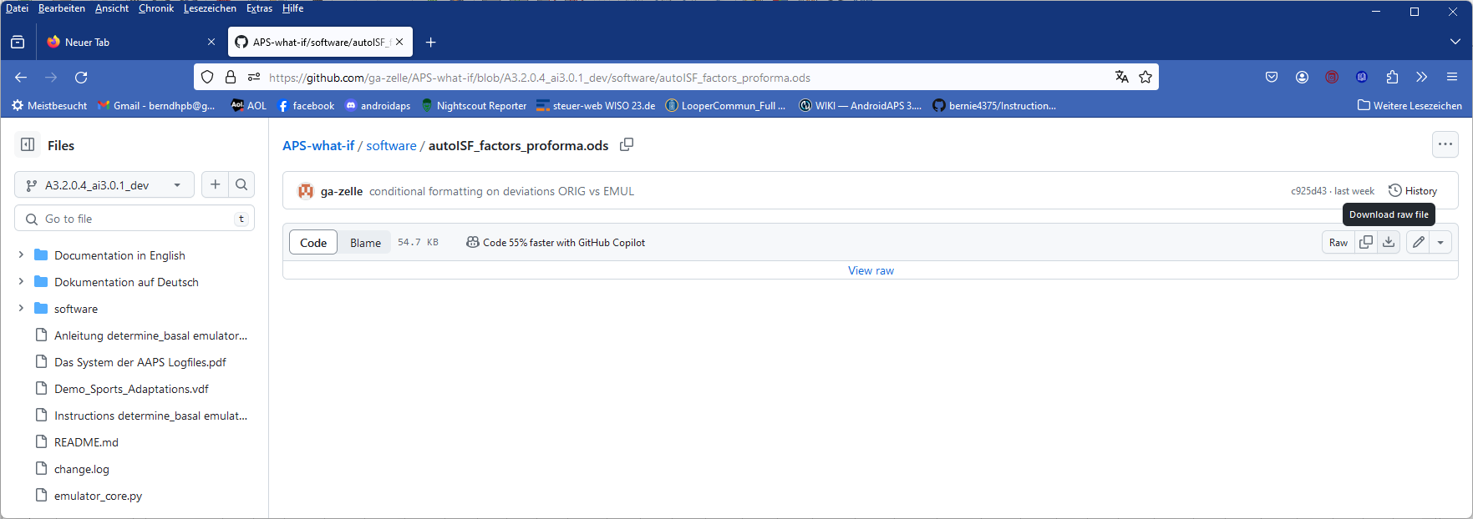

Put that file on your PC one level above the single files for all your studies:

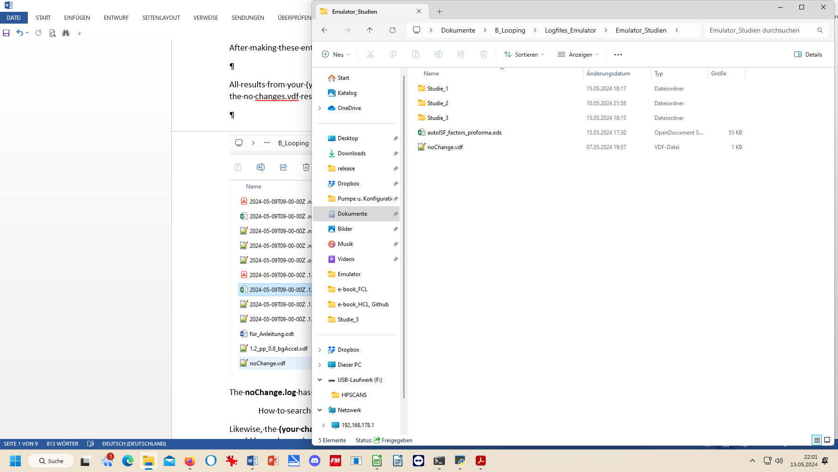
2).Now, if we want to use this tool on the two csv files of our Studie_3 file, we must proceed as follows (for each of the two .csv files, separately):

- Click on the .csv file and open in Libre office calculator.
- Make sure the time column is set to US_English:
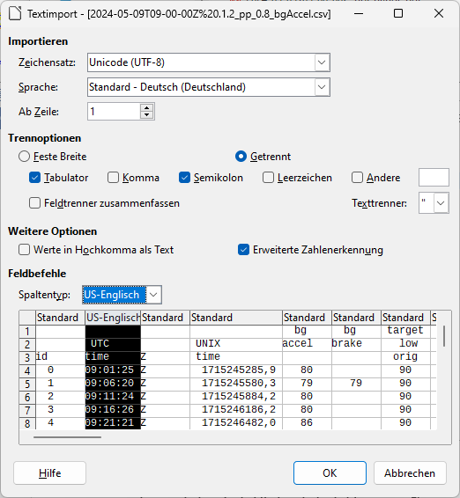

3).Now start, in Libre office calculator, the autoISF_factors_proforma.ods …
This turns the first 30-some lines of your csv table (left side) into a form in which important effects are highlighted in color, and formatting is improved:
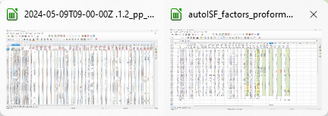

Now, you want this for the entire table.
4).In the autoISF_factors_proforma table, highlight 20 or more lines (not including the first or last), and mouse right hand/insert above … 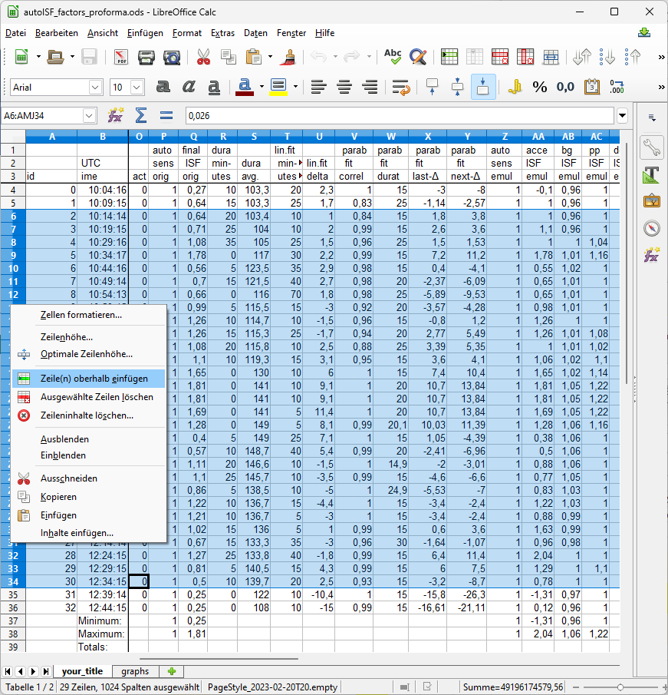

Do this as often as you need to create the number of lines that your emulated csv file comes with.
If you ended up with too many lines, erase the superfluous number (any four, in the example):
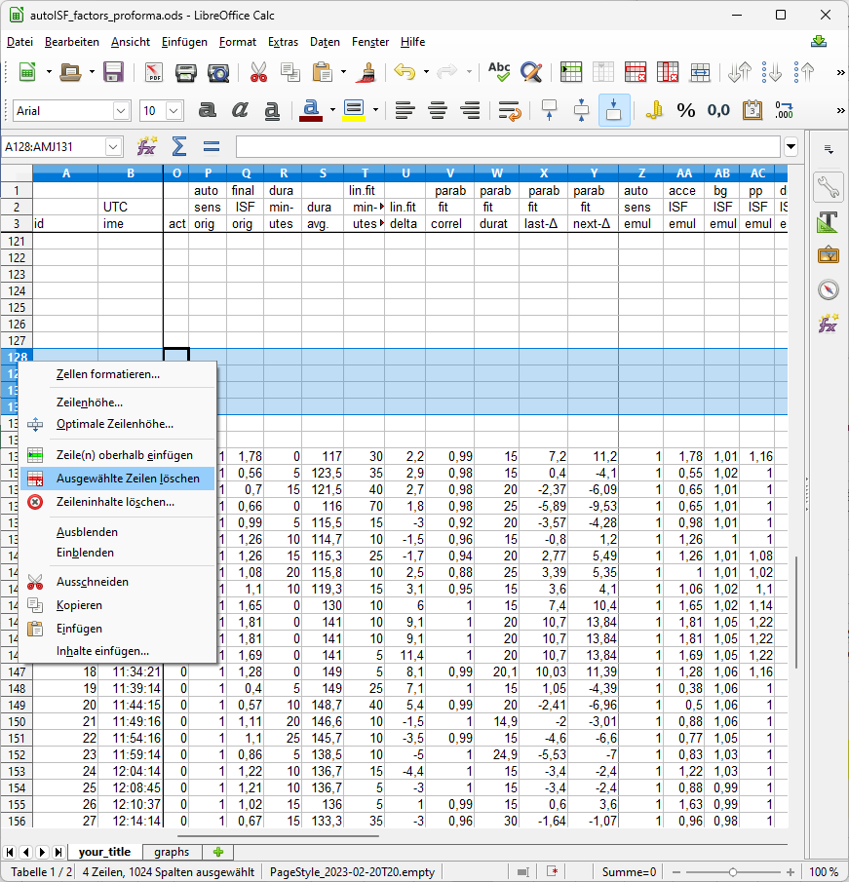

5).Then just copy it in, by selecting all data lines in the emulated csv, and pasting (paste special, values only) into box A4 of your “elonged” autoISF_factors_performa.ods.

6).The bottom tab “your_title” should be re-named by you, best with day of log you analyze, and your what-if parameters (so, the name of your csv file could be put in here)

Now you have a table with optimized lay-out that incorporates key data from both your no change AND of your investigated changes.csv files.

A similar table is available on the (i-)phone if you use the autoISF dev variant of iAPS or Trio (see section 11.3)

7).A super neat extra feature is already pre-programmed, which you can see if you click on the bottom tab “graphs”.

The top graph is the bg curve (the actually seen bg).
Note that for the what-if no bg development over the time range is available. (The noChange one is also given there).
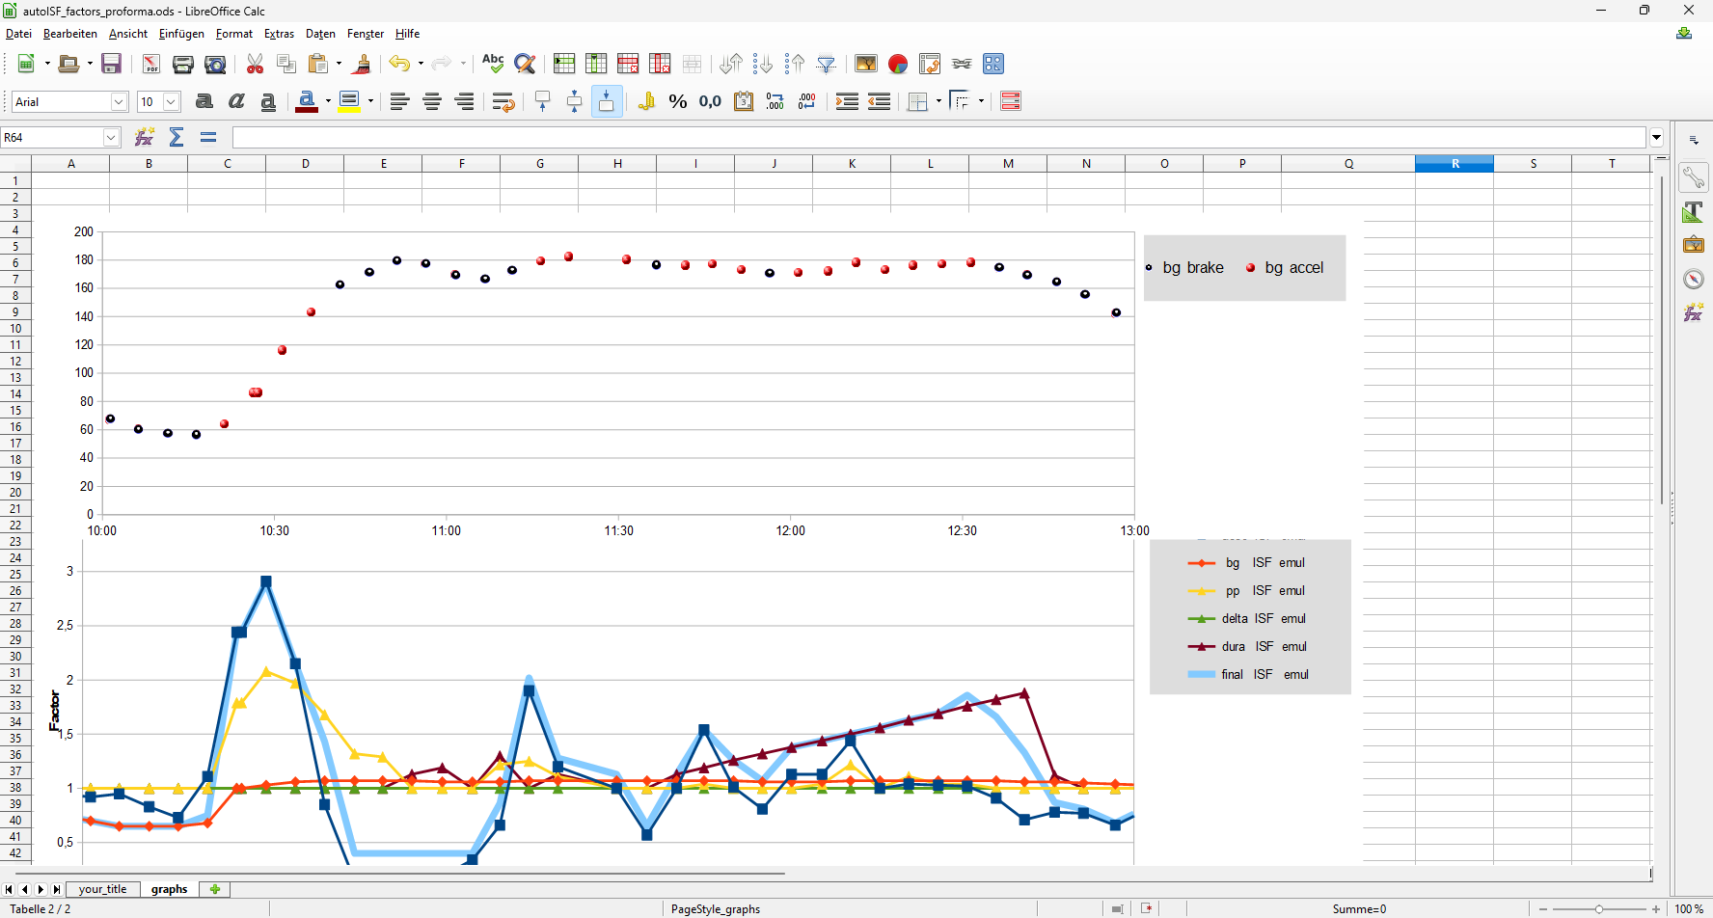
accel_ISF
< 1 brake_ISF

The bottom graph (do one for each, the noChange or the (yourChanges) case) shows the amplification factors coming from each autoISF category, and the overall resulting ISF amplification.

You probably have to widen the time scale (double click on the time axis, and type the desired time span (min and max UTC)(and spacing of data points, 00:30:00 or 00:15:00) into this box:
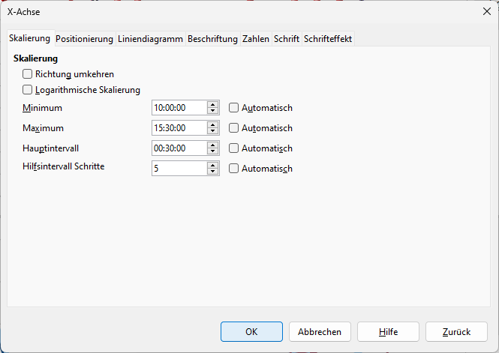
In the given example above, the 2.5 hours were not enough yet to analyze this 10:30 UTC (12:30 AAPS) lunch; we need to look until bg is near target (hopefully before dinner starts).

10.3.3.4 Chart coming with the emulator

In case you find the extra steps described in the preceding section “too much”: Also the emulator offers one chart (the pdf offered at the bottom of the screen as shown below the “10.3.3 Emulaton results” headline).

First look at the initial bg rise in the noChange.pdf chart (emulation results from your noChange.vdf run), and see how bgAccel_ISF and pp_ISF acted, or could have acted in improved ways.
Then look into in (yourChange).pdf to see potential effects (or what other change to try). (Actually, you probably will have to go into a detailed analysis of several lines and columns of the tables as discussed in sections 10.3.3.2 and 10.3.3.3).

Note that ideally we want FCL coverage of our entire “normal day” meal spectrum by one set of settings.
So, not much is gained if you put a lot of effort in optimizing FCL settings for one meal.

You will need iterations. Do such analysis for two or three very different meals that you wish the algorithm to automatically handle. See section 4.2/4.3 on how meals with very different carb loads might benefit or also suffer from aggressive or mild (category)_ISF_weights you could set.

The initial iob received might be limited by allowed SMB sizes, autoISFmax, or the (dynamic!) iobTH. You will have to look into the data table to find out about this (a quick orientation - notably regarding the light blue iobTH band, see next page - is also possible in the pdf result files you have in your project file (project file example “Studie 3” in 2nd chart under the 10.3.3. headline).
Only once you found OK weights for bgAccel- and pp_ISF_weights, does it make sense to go tune the dura_ISF_weight. 12:00 – 12:45 UTC in above graph, the resulting effective ISF is dominated by dura_ISF. Just judging from the picture, a stronger weight might be worth trying. However, we really need to see the insulinRequired calculation and the further development because impatience about bringing bg values down faster too often results in hypoglycemia later.

The noChange.pdf is a chart that shows along the time axis (down), from right to left:
- Red: the bg curve
- Yellow: the bg target (note that I do no manual “EatingSoonTT” but for bg rises over +10 mg/dl I have an Automation that sets low TT for a couple of minutes)
- Light blue corridor: Left edge is set iobTH, and bandwidth +30% (would be +20% at elevated TT)
- Dark blue line: iob (exceeding twice the iobTH, with temp. SMB shut-off
- Orange line: cob = 0 in FCL
iob
iobTH
1.2 bgAccel …
noChange
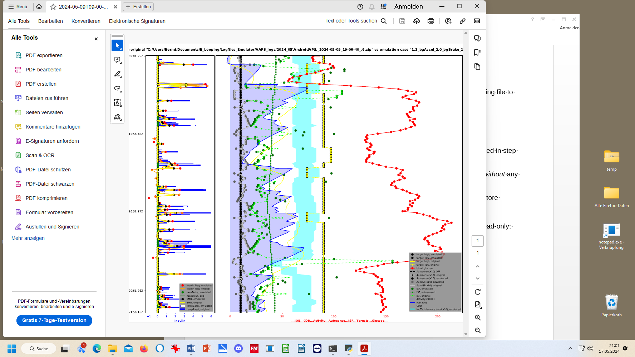

Earlier stronger ISF would lower the 1st bg rise. (earlier exceed iobTH which also could be elevated a bit).


- As bg did not convincingly come down enough, one could hypothesize that iobTH should be elevated. ((But, again, this would have to be confirmed also with other kinds of meals)).
- Thin yellow line: Insulin activity
- Green dotted line: ISF as would result from AAPS w/Autosens
- Green scatter points: autoISF ISF no Change (lighter points) or what-if (darker points)
Foreseeably, this is the strongest difference between our noChange (left) and 120% bgAcel_ISF_weight (right) in the picture below. (Note the red bg curve is both times the really seen bg, because the what-if case only looks at each single loop decision). The first ( -> ) time the dark green dot is far to the right, this would get the bg down, we would start to see a ( <- ) bg lowering effect, shifting the red curve to the left
- Black line: Profile ISF
- Gray scatter points: ISF weakened (to the left of black line) or strengthened (to the right)

Regarding the other changed parameters: Stronger dura_ISF would suggest more insulin towards the end of plateaus; this should have helped in the 1st plateau (red curve, top right quadrant of the picture). However, same setting would have to work also on 2nd plateau; the chart cuts off there, so too early to see whether a hypo danger might result.
Effect from doubling the bgBrake_ISF effect are hard to evaluate. Better probably to look in .csv tables, or run a separate emulation for that change only.

Always check for 2 or 3 kinds of your meals whether the “new” parameter settings really are on average better. (See negative example in case study 8.2!)

Part of both above shown charts (left side of each, with blue peaks) was cut out.….
(unfinished / to be explained later) (Here: yourChange = 1.2_bgAccel_2.0_bgBrake_1.2_dura)
noChange
1.2 bgAccel …



10.3.3.5 delta
In case you want to analyze delta, short and long average deltas, see section 10.2.4.5

To analyze deltas in a “what-if” scenario really does not make much sense, because effects from each single change ripples through many subnsequent situations and it is impossible to preduict how glucose curve, and therefore also how deltas, would develop in the what-if case.
Final remark

Please share your experiences with the emulator in Discord / Full-Closed-Looping / HOW TO /_emulate-aaps, at: https://discord.gg/n3tD5eXExC

10.3.3.5 delta table from “what-if” run with (yourChange).vdf

In case you want to analyze delta, short and long average deltas, see section 10.2.4.5

To analyze deltas in a “what-if” scenario really does not make much sense, because effects from each single change ripples through many subsequent situations, and it is impossible to predict how glucose curve, and therefore also how deltas, would develop in the what-if case.

